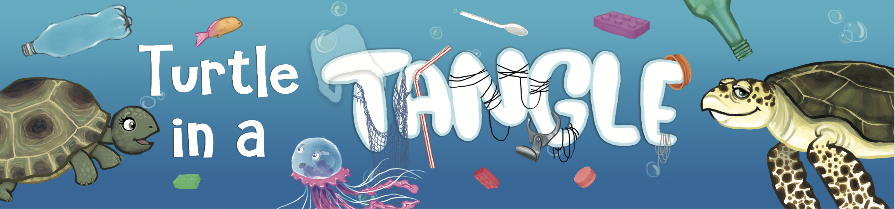

What do you think Pebble and Zoom would be saying to each other?

