**Turtle in a Tangle**

Can you think of adjectives to describe the sea life in this picture?

Have a look in the book to see if you can find the adjectives the author has used.

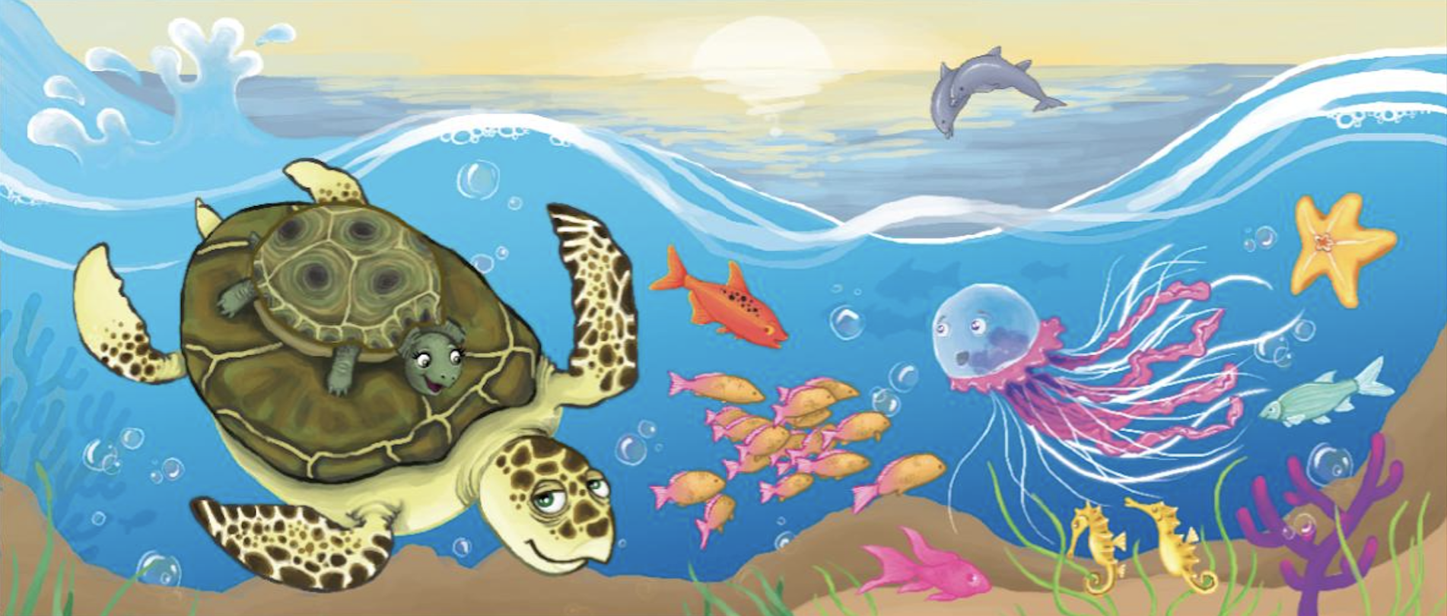

**Dolphins**

_____________________________

_____________________________

**Jellyfish**

_____________________________

_____________________________

**Seahorse**

_____________________________

_____________________________

**Seaweed**

_____________________________

_____________________________

**Starfish**

_____________________________

_____________________________

**Fish**

_____________________________

_____________________________

Now use your ideas to write sentences about what you can see.

_________________________________________________________________________________________________________

_________________________________________________________________________________________________________

_________________________________________________________________________________________________________

_________________________________________________________________________________________________________

_________________________________________________________________________________________________________

_________________________________________________________________________________________________________