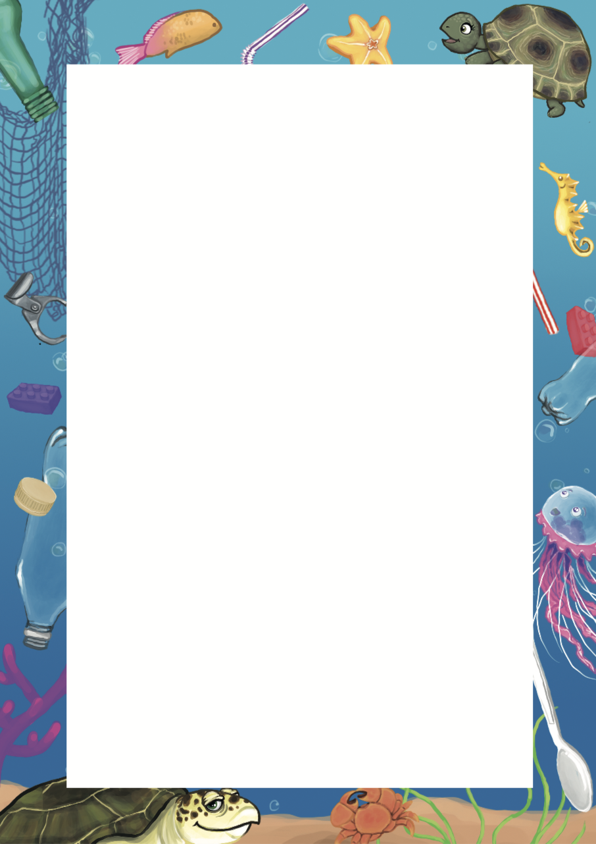

**Turtle in a Tangle**

1. How do you think Pebble felt when she fell into the water?

_______________________________________

1. Why do you think Pebble thought the huge creature was going to gobble her up?

_______________________________________

1. Why do you think the tortoise is called Pebble and the turtle is called Zoom?

_______________________________________

1. Why did Pebble always win hide and seek?

_______________________________________

1. What do you think Pebble was thinking when she was waiting for Zoom?

_______________________________________

1. How do you think Zoom felt when she saw Pebble clinging on to the jellyfish?

_______________________________________

1. How do you think the sea creatures felt when they saw the people taking the plastic away?

_______________________________________

1. How are you going to help?

_______________________________________

_______________________________________